**DATA COMMUNICATION & NETWORKING LAB**

***CEL 222***

Lab 3



MALIK ZOHAIB MUSTAFA

01-134192-030

BSCS-4B

# Department of Computer Sciences

**BAHRIA UNIVERSITY, ISLAMABAD**

# Q1: Building and testing a Peer-to-Peer network

**Tasks:**

## Introduction (IP Assigning)

## Data Sharing

## Internet Sharing

## Resource Sharing

1. **Introduction.**

|  |
| --- |
| Peer-to-peer computing or networking is a distributed application architecture that partitions tasks or workloads between peers. Peers are equally privileged, equipotent participants in the application. They are said to form a peer-to-peer network of nodes  In its simplest form, a **peer-to-peer** (**P2P**) **network** is created when two or more PCs are connected and share resources without going through a separate server computer. A **P2P network** can be an ad hoc connection—a couple of computers connected via a Universal Serial Bus to transfer files. In a P2P network, no single provider is responsible for being the server. Each computer stores files and acts as a server. Each computer has equal responsibility for providing data.  P2P is ideal for sharing files. P2P would be unsuitable for a service such as booking tickets, as one server needs to keep track of how many tickets are left. Also, on P2P networks no single computer is responsible for storing a file - anyone can delete files as they wish.  **Advantages:**   * No need for a network operating system * Does not need an expensive server because individual workstations are used to access the files * No need for specialist staff such as network technicians because each user sets their own permissions as to which files, they are willing to share. * If one computer fails it will not disrupt any other part of the network. It just means that those files are not available to other users at that time.   **Disadvantages:**   * There is little or No central control over security besides the permissions. Users often do not need to log onto their workstations. * Files and resources are not centrally organized into a specific 'shared area'. They are stored on individual computers and might be difficult to locate if the computer's owner does not have a logical filing system. * If machines on the network are slow, they will slow down other machines. * Each computer must be backed up. Data can easily be deleted by users.   **IP ASSIGNING:**   1. Open software packet tracer 2. Click End Devices icon (lower left corner) or press CTRL + ALT + V 3. Drag icon general (Personal Computer) and drop to worksheets.      1. Click Connections icon or press CTRL + ALT + 0 , then click Automatically Choose Connection Type. 2. Click PC0 then click PC1.      1. Double click PC0. 2. Desktop tab, then click IP Configuration.      1. Set IP Address for Subnet Mask. IP Address PC0 = 192.168.2.1 Subnet Mask = 255.255.255.0( will automatically assign after inputting ip)      1. Close window PC0 2. Double click PC1 3. Desktop tab, then click IP Configuration. 4. set IP Address for Subnet Mask. IP Address PC0 = 192.168.2.2 Subnet Mask = 255.255.255.0      1. Desktop tab, then click Command Prompt      1. Type ping 192.168.2.1 then enter      1. Connection Successful. And IP ADDRESS is Assigned Successfully. |

**Data Sharing:**

One of most basic ways to share files and other resources with another computer in an office is via an Ethernet Cable. However, we cannot use a regular Ethernet cable -- called a straight-through or a patch cable -- to accomplish this. Instead, we need a Category 5, or CAT 5, or later crossover cable. After the connection, We Assign IP then we go to properties of the file we want to share and enable sharing. . You can also do this password protected. To access the data, go to Run program and then type IP Address of 2nd computer(the computer you want to access) and then click ok then you can access the data of that computer.

|  |
| --- |
| **In above part ,4 Replies came so below is illustration of all the messages(packets) send and received** |

## Internet Sharing

Connect the two computers via a standard ethernet cable. (You used to have to use a crossover cable, but PCs are clever enough these days to not require one.) Then go to the Network and Sharing Centre in the Control Panel, “Change adapter settings,” right-click the adapter that has the Internet connection (Wi-Fi in my case) and click Properties.

In the Properties box, click the sharing tab and tick the “Allow other network users to connect …” box. Next, click the drop-down under “Home networking connection,” and select the ethernet adapter that is connecting your two PCs together.

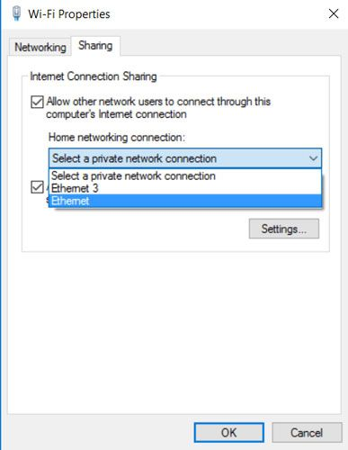

That should do it! If it does not work for some reason, then go to adapter settings in the Network and Sharing Centre on the PC that you are trying to get online, right-click the ethernet adapter, disable it, then enable it again.

### **Network Bridge**

If that does not work out for you, then instead of fiddling around with things like setting a static IP, you can jump straight to this like-for-like method, which should be quicker.

First, turn off connection sharing on your network by unticking the “Allow other network users to connect …” box on your connected adapter and hitting OK. Now, in the “Change adapter settings” window, hold the “Ctrl” key, then click the adapter that is connected to the Internet and the one that you are trying to connect.

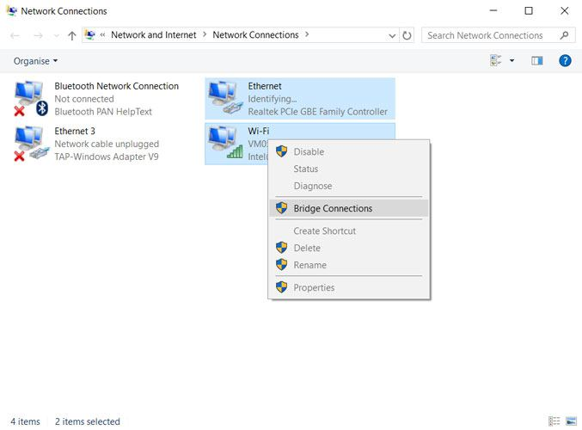

Next, right-click one of the adapters and click “Bridge Connections.” That ought to do it. Again, you may need to disable then re-enable the network adapter on the PC looking to receive the connection for this to work.

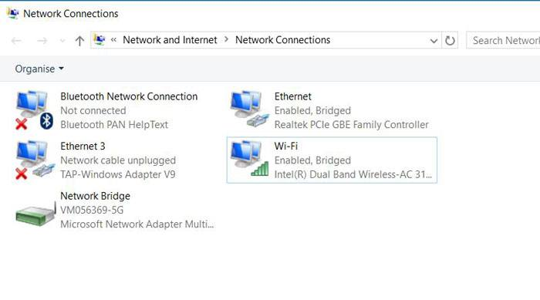

## Resource Sharing

## Organizations can connect two workstations to a single printing device using a peripheral switch (a device that simultaneously connects multiple PCs to one peripheral) or homegroup (an alternative to a workgroup, in Windows). Using one of these methods enabling employees to access the printer from either computer, as needed. Administrators can install a peripheral switch for local printers (which is especially helpful if the printers do not support Wi-Fi) and instead connect to a PC through a Universal Serial Bus (USB) cable or set up a homegroup to share a wireless printer with both computers on the network.

#### **Steps:**

* Select the "Sharing" tab. Click to place a check mark in the "Share This Printer" check box and either enter a name for the shared device or use the default name. Click "OK."
* Click "Back" to return to Control Panel Home. Click "Network and Internet" and then "Homegroup."
* Click "Create a HomeGroup" and follow the onscreen instructions to share printers on the network. Print or write down the password provided.
* Sign on to the other computer and open HomeGroup from the Control Panel.
* Click the "Join now" button and follow the on-screen instructions to connect to the other PC.
* Return to Control Panel Home, click "Devices and Printers," and click "Add a printer."
* Select "Add a network, wireless or Bluetooth printer" and then "The printer that I want isn't listed."
* Choose "Select a shared printer by name" and then click "Browse." Choose the other PC and then click "Select."
* Double-click the shared printer and then click "Next." Follow the remaining instructions on the screen to complete the installation.